Harpreet Singh

041127993

Lab Assignment 01 Worksheet

# Part 1 Connecting to printers on campus (1 mark)

No screen shot required, print your demonstration sheet, and bring to lab for demonstration, the physical demonstration sheet itself is worth 1 point.

# Part 2 Basic Operating System Maintenance (4 marks)

(2a) Screen shot showing operating system is updated:

(2a) Screen shot showing antivirus is updated:

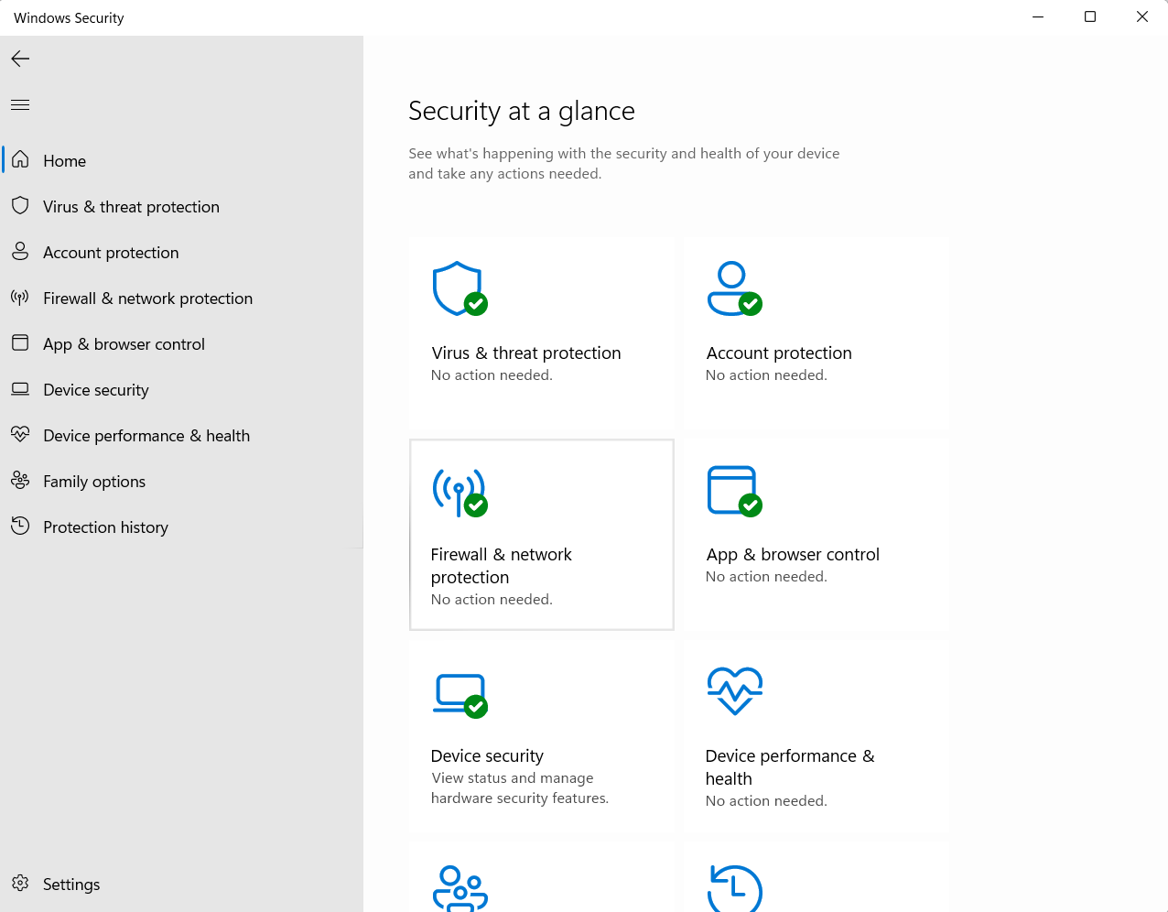

(2b) Screen shots showing use of ipconfig as requested

Folder PATH listing for volume Windows

Volume serial number is 628C-FD9A

C:.

│ index.txt.txt

│

├─── Theory class essentials

│ week 1

│ week 2

│ week 3

│ week 4

│ week 5

│├─── lab course essentials

│ lab activity00

│ lab activity01

│ lab activity02

│ lab activity03

│ lab activity04

│ lab assignment01

192.168.2.65 IP ADDRESS

(2b) Screen shots showing use of net start and net stop as requested

# Part 3 Managing files (2 marks)

Copy and paste the output from the tree command here:

# Part 4 Create a windows backup and restore file(s) from it (2 marks)

Screen shot of backup tool showing that a backup was created:

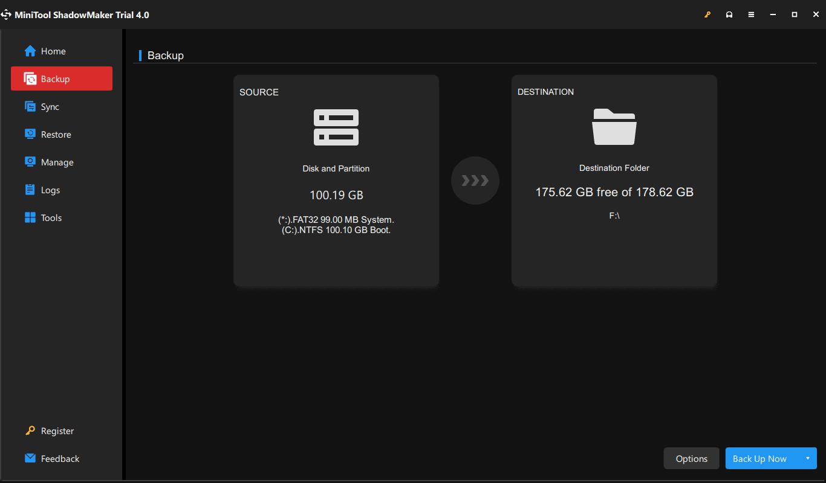

# Part 5 List the specifications for a computer (1 mark)

Hyperlink to reference laptop used as source of computer specifications:

**Laptop:** ASUS ZenBook 14 (14” Touch Laptop) [1]  
**Price:** $1,549 (Staples Canada)​

**Specifications:**

* **CPU:** Intel Core i7-1260P (2.1 GHz, 18MB cache)
* **Cores:** 12 cores (4 performance and 8 efficiency cores)
* **RAM:** 16GB LPDDR5
* **Storage:** 512GB PCIe SSD (Solid State Drive)
* **Graphics Processor:** Intel Iris Xe Graphics (integrated, shared memory)
* **Ports:**

1x USB 3.2 Gen 2 Type-A

2x Thunderbolt 4 (supports display and power delivery)

1x HDMI 2.1 TMDS

1x 3.5mm audio jack

[1]1x Micro SD card reader

This laptop provides a good balance between performance and portability with its high-speed processor and ample storage, suitable for various tasks

# References

|  |  |
| --- | --- |
| [1] | "[staples," [Online]. Available: https://www.staples.ca/products/3059228-en-asus-zenbook-14-14-touch-laptop-intel-core-i7-1260p-512gb-ssd-16gb-ram-windows-11-blue.](https://algonquinlivecom-my.sharepoint.com/:p:/g/personal/harp0183_algonquinlive_com/EZ2kL67drR1AsLGipgQu63sB5oX4R1XsajnJeZtNuqDdCA) [Accessed 11 10 2024]. |

Computer Specifications as requested: